Satisfactory Academic Progress (SAP) Policy for Financial Aid

General Information
The federal financial aid programs at UNCP are authorized under Title IV of the Higher Education Act of 1965, as amended. The Act states that a student must maintain satisfactory academic progress in the course of study s/he is pursuing, according to the standards and practices of the institution at which the student is in attendance. The federal Title IV programs include Federal Pell Grants, Federal Supplemental Educational Opportunity Grants, Federal Work Study, Federal Stafford Loans (subsidized and unsubsidized), Federal Perkins Loans and Federal PLUS loans. For purposes of consistency and equity among all students, UNCP applies the following standards to all students receiving federal Title IV aid and all students receiving any other financial aid, including institutionally and state funded sources.
All students (full time, part time, graduate and undergraduate) who wish to qualify for financial aid while attending UNCP must meet certain standards of Satisfactory Academic Progress (SAP). These standards include a minimum cumulative grade point average (GPA), a minimum credit hour completion rate and the completion of a degree or program of study within a maximum number of credit hours.
For purposes of determining satisfactory academic progress status and eligibility for financial aid, a student's academic record is evaluated by reviewing a student’s cumulative academic performance after each semester has concluded (fall, spring, summer). If a student has a break in enrollment or is suspended or dismissed, then his/her SAP will be reviewed upon the student's return to UNCP. This evaluation will include a student's entire academic record at UNCP and will compare the student's academic record to the standards of Satisfactory Academic Progress. These standards are applied to all semesters or terms during which the student was enrolled, regardless of whether the student received financial aid for those prior terms of enrollment.
Students who fail to meet one or more of the SAP standards at the time their progress is reviewed, the appropriate SAP status is applied. Students who are placed on “Financial Aid Warning” are still eligible to receive financial aid for that payment period. If students are placed on “Bad SAP”, they are not eligible for financial aid, including summer terms. The Office of Financial Aid and Scholarships will notify students of their failure to meet the standards of SAP. Each student is responsible for knowing his/her own status, whether or not s/he receives this notification. Students may view their SAP status via BraveWeb or by contacting the Office of Financial Aid. Students are eligible for financial aid during their warning semester.
Satisfactory Academic Progress is not the same process as Academic Standing. Academic Standing reviews GPA while Satisfactory Academic Progress reviews GPA, completion rate, and timeframe.

Minimum Cumulative Grade Point Average (GPA):
Undergraduate students' cumulative grade point average (GPA) must meet the University standards of a 2.0 for all attempted hours.
Graduate students must maintain a cumulative GPA based upon the number of credits attempted as follows:

Number of Attempted Credits | Minimum Cumulative GPA
o0-9.999 | 2.0
10-20.999 | 2.4
21-27.999 | 2.7
28-Above | 3.0

Financial aid eligibility will be canceled immediately for any student who is academically suspended or academically dismissed. Students remain ineligible for financial aid during the dismissal or suspension period.

Minimum Credit Hour Completion Rate:
All students must earn a minimum of two‐thirds or 67% of the credit hours that they have attempted including transfer hours. To determine a student's credit hour completion rate, divide the total earned credit hours by the total number of credit hours attempted at UNCP.
Example: The student below has earned 82 credit hours at UNCP and transferred in 62 earned hours for a total of 144 earned credit hours. This student has attempted 109 hours at UNCP and transferred in 62 attempted hours for a total of 171 attempted credit hours. Divide 144 (earned credit hours) by 171 (attempted credit hours). This student's credit hour completion rate is 84%.

 | Attempted Hours | Passed Hours | Earned Hours | GPA Hours | Quality Points | GPA
UNCP | 109 | 82 | 82 | 90 | 202.90 | 2.254
Transfer | 62 | 62 | 62 | 0 | 0 | .000
Degree | 171 | 144 | 144 | 90 | 202.90 | 2.254

Rounding Policy for SAP Evaluations:
UNCP applies standard rounding rules to the quantitative (pace of completion) components of Satisfactory Academic Progress (SAP). Specifically, when credit hour completion rate, numerical values ending in 0.5 or higher will be rounded up to the next whole number, and values below 0.5 will be rounded down.
For example:
- A completion rate of 66.5% will be rounded up to 67%, meeting the minimum pace requirement.
This rounding procedure is applied uniformly across all SAP reviews and to all student categories receiving Title IV federal aid. A student is either meeting SAP standards for all federal aid programs or is not. Rounding will not be used selectively or to qualify a student for one type of federal aid but not another.

Completion of a Degree or Program of Study within a Maximum Time Frame:
Each student has a maximum time frame during which s/he can receive financial aid. To remain eligible for financial aid at UNCP, undergraduate and graduate students must complete their degree program requirements within 150 percent of the published length of their degree program. All attempted hours are counted, including transfer hours, whether or not financial aid was received, or whether or not the coursework was successfully completed. As we perform our annual review of each student’s Satisfactory Academic Progress, if it is mathematically impossible to graduate within 150% of the academic program
length, students are ineligible for financial aid.

As an example, if an undergraduate degree program requires 120 semester credit hours to complete, then a student is eligible for financial aid during the first 180 attempted credit hours. (120 x 150% = 180 maximum attempted credit hours for financial aid eligibility).
A student's academic load is determined at the end of the drop/add period each semester. If a student reduces his/her course load below the minimum, the Office of Financial Aid must be notified, and some aid funds may have to be repaid. The student is responsible for notifying the OFA if a reduction occurs or is contemplated.

Time Frame Credit Hour Exclusion
To accommodate students that transfer credits into UNCP, we will exclude transfer hours from the calculations that are not applicable with the student’s current academic program. This will allow students to not be penalized based on their previous academic efforts.

Undergraduate Second-Degree Students
A student working toward a second or subsequent baccalaureate degree is expected to make the same satisfactory progress and enroll for the same minimum course load when receiving financial aid as that stated above. The number of hours is not reset based on completion of a prior Undergraduate degree.

Grades
To earn hours at UNCP, a student must receive a grade of A, B, C, D, or P including + or ‐. All other grades including F, I, W, AU or NR do not earn hours.

Withdrawals, Incompletes, Audited Coursework
Withdrawals and incompletes are considered attempted but not earned hours. These grades are not included in the GPA calculation, but they are included in both the minimum credit hour completion rate and maximum timeframe calculations. Therefore, withdrawing from classes after the drop/add period or receiving incomplete grades will negatively affect the student's ability to maintain satisfactory academic progress.
Audited courses are not considered as attempted nor earned credits. Financial aid is not awarded for audited courses.

Repeated Coursework
If a student repeats a course, both the original course and the repeated course will count toward attempted and earned credit hours. Both attempts will also count in the GPA calculation in accordance with the University's Repetition of Coursework policy. Students should be aware that financial aid may not cover all repeated courses.
Most financial aid programs will cover only one repeat of a previously passed course. Students considering repeating a previously passed course are strongly encouraged to consult with the Office of Financial Aid regarding repeated coursework.

Regaining Eligibility for Financial Aid
Students who have failed to meet one or more of the SAP requirements are not eligible for financial aid. However, financial aid eligibility may be regained if:
- The student raises his/her cumulative GPA to the minimum standard as defined in this Satisfactory Academic Progress Policy requirements through hours earned at UNCP within the student's program of study (without financial aid).
- And/or, the student's credit hour completion rate has been brought up to the standard as defined in this Satisfactory Academic Progress Policy requirements by successfully completing coursework within the program of study at UNCP (without financial aid).
- And/or the student appeals his Satisfactory Academic Progress following the appeals process and receives an approval from the departmental or committee level.

Appeals Process
Students who do not meet satisfactory academic standards will be subject to a strict monitoring policy and appeals process with the intention of moving the students toward academic progress and graduation. Student grades will be reviewed by reviewing a student’s cumulative academic performance after each semester has concluded (fall, spring, summer) for the following academic year unless the student has a break in enrollment or is suspended/ dismissed, then SAP will be reviewed at that time.
The monitoring policy and appeals process is as follows:
Financial Aid Warning- Warning status lasts for one payment period only, during which the student may continue to receive Title IV funds. Students who fail to make satisfactory progress after the warning period lose their aid eligibility unless they successfully appeal and are placed on probation.
Financial Aid Probation - If a student does not meet satisfactory academic progress, s/he will be denied his/her financial aid. The student will be allowed to appeal this decision by submitting an appeal which must include
- An attached academic plan that, if followed, will ensure that the student is able to meet this SAP policy by a specific point in time. A staff member from the Center for Student Success will meet with the student to complete the Financial Aid Academic Progress Improvement Plan that outlines how tutoring or other support services provided by the University will be used to help assure academic improvement in the future and will report on the student's compliance with the plan at the end of the probationary semester(s).

- A detailed description of the extenuating circumstances that occurred during the time frame in which the student failed to meet this policy.
- All necessary documentation to support the existence of the circumstances described in #2 and what steps are being taken to resolve the situation.
Events/circumstances that merit an appeal include, but are not limited to:

  - Personal or family emergency
  - Death or extended illness of an immediate family member which results in greater family responsibilities for the student
  - Unanticipated, serious medical difficulty (excluding chronic conditions - students are responsible for properly balancing schoolwork with known chronic conditions)
  - Serious psychological difficulty

Documentation Required:

Documentation must be provided with your appeal for it to be considered by the Committee. Examples of documentation include, but not limited to, the following:
  - Grade Reports that show academic progress
  - Email documentation from faculty, staff or administration that documents your situation
  - Letters from SHS (Student Health Services), CAPS (Counseling and Physiological Services), PCP (Primary Care Physician) and/or CARE Team: These do not need to explain your issue, but they can confirm the situation that required you to request an appeal.
  - Correspondence from Housing and Residence Life staff that document your situation
  - Police Reports and/or Landlord Reports
  - Work Schedules and/or Letters from Employers explaining the situation
  - Students on Max Time Frame (150%) need to provide an educational plan from their advisor indicating:
    - Anticipated Graduation Date
    - How many credits student needs to complete degree
  - Any documentation that will explain why you are not making Satisfactory Academic Progress

The appeals and all attached documentation will be reviewed by a committee. If a student's appeal is approved, s/he is subject to the probation requirements as follows:
The Center for Student Success will advise the student about which category the student is required to adhere to,

- GPA requirement:
  - No earned grades below a C (including a C‐)
  - No incompletes (grades of I)

- Completion Rate requirement (Pace Requirement):
  - No withdrawals (grades of W)
  - No incompletes (grades of I)

Students seeking to reestablish eligibility for financial aid by submitting an appeal remain ineligible for financial aid or deferment of payment until the appeals process is complete and a decision has been determined by the department or SAP committee.
Students should be prepared to pay tuition, fees and other educational expenses until s/he has been approved to receive financial aid.
If a student's appeal is not approved, that student will not be eligible for financial aid. A student whose appeal has been denied cannot appeal again unless there are material changes in his/her academic record. Material changes to an academic record may include, but are not limited to, processing grade replacements, clearing an incomplete, successfully attending another institution
and transferring the credit back to UNCP or attending a semester at UNCP at the student's own expense and meeting all three of the SAP standards.

If the SAP appeal was denied by the Committee the student may reach out to the Director of Financial Aid and Scholarships to request that their SAP appeal be reviewed by the Vice Chancellor of Enrollment Management. The Vice Chancellor of Enrollment Management can overturn the committee’s decision if the student can provide supporting evidence and documentation that proves there have been material changes in their appeals case.

Now Good Appeals – Students who take classes out of pocket or transfers in hours from other institutions can submit a Now Good Appeal if they are now in good financial aid standing. Students must be meeting both the undergraduate or graduate GPA requirements and 67% completion rate (Pace) to be eligible to submit this type of appeal. These appeals are usually submitted when the Financial Aid Office is between SAP processes.
Change of Majors
All hours attempted regardless of major changes will be included in the SAP calculation.

SAP Appeal Process At-A-Glance

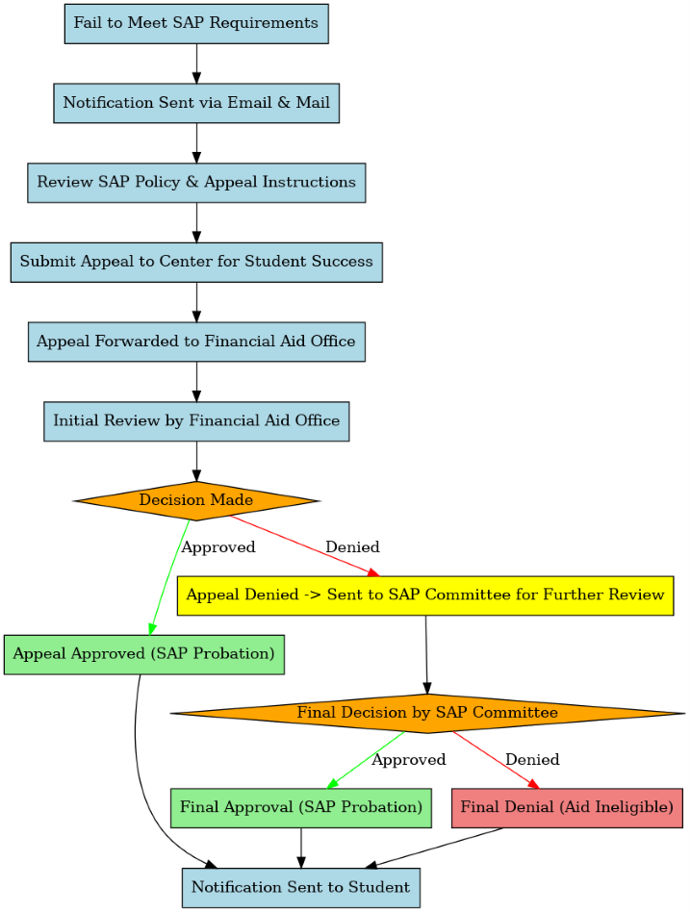

If the SAP appeal was denied by the Committee the student may reach out to the Director of Financial Aid and Scholarships to request that their SAP appeal be reviewed by the Vice Chancellor of Enrollment. The Vice Chancellor of Enrollment can overturn the committee’s decision if the student can provide supporting evidence and documentation that proves there have been material changes in their appeals case.

